**TestNG Annotations:**

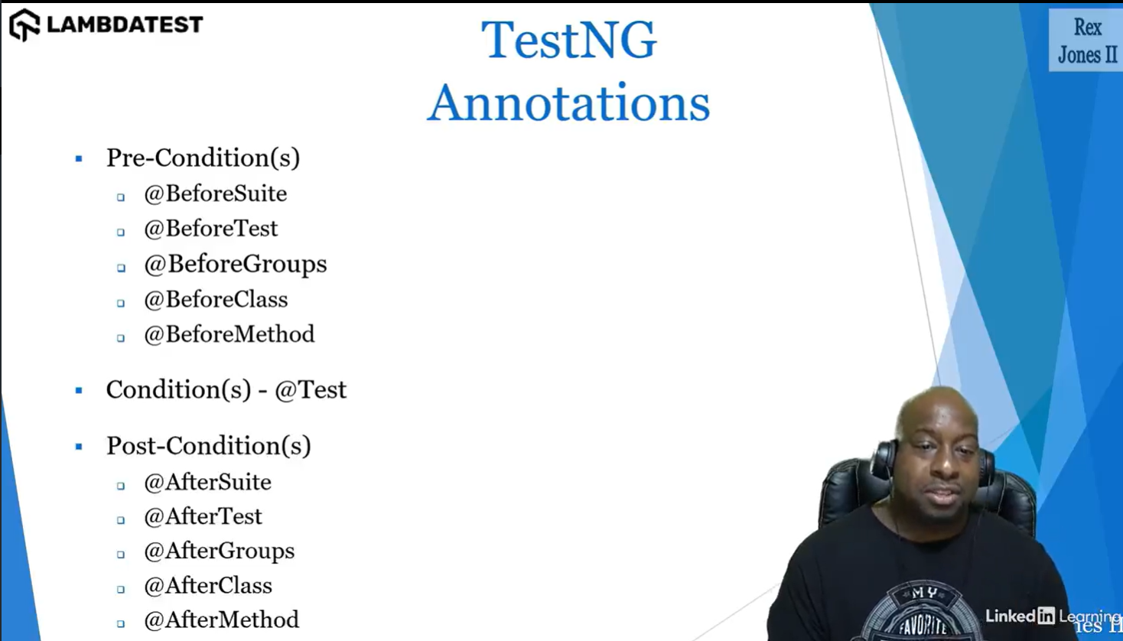

**Assertions in TestNG:**

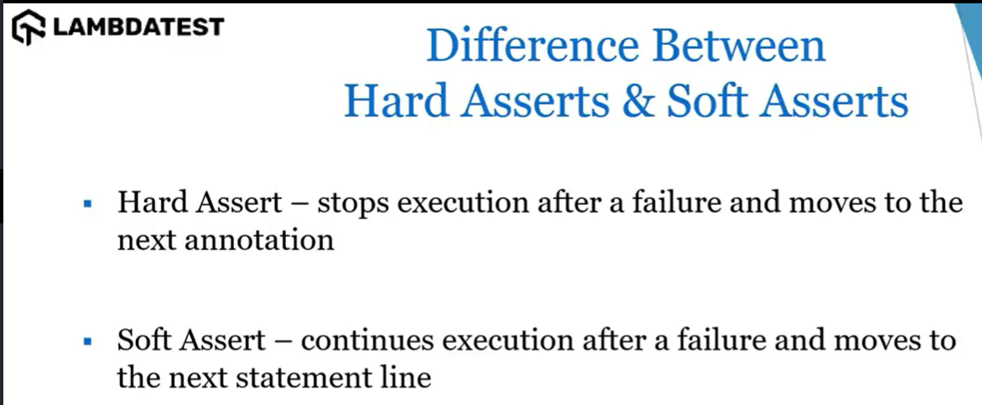

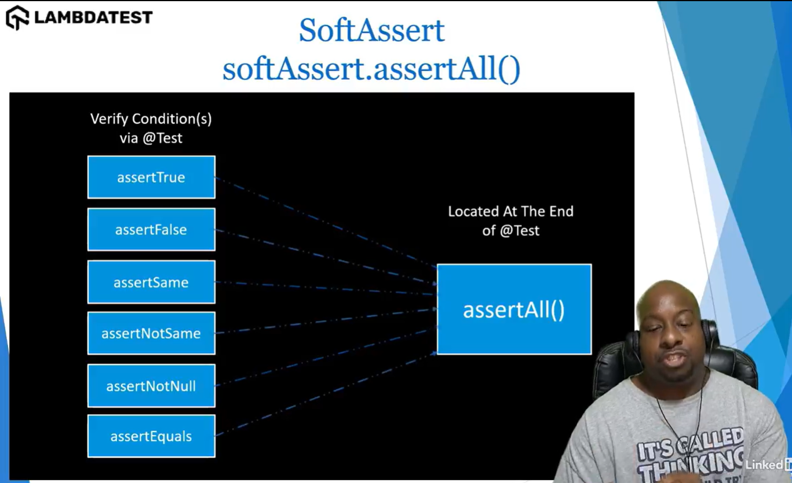

**Note:** If you verify more than one assertion then its better to use Soft Assertion, for one we can use Hard Assertion.

